• Understanding JSX

Within class App extends Component:

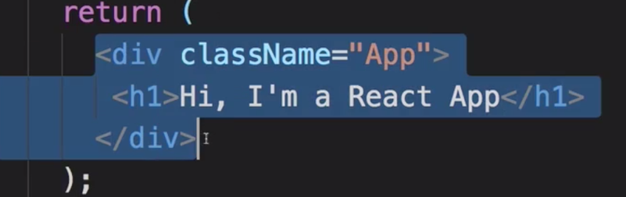

This is not HTML. This is JSX, which is syntactically similar to HTML, which is compiled the same as the one below.



Since it’s hard to write React.createElement for every element, we use the first syntax (JSX) to create elements. React.createElement (which is imported from React) takes at least three functions: 1) Element type, 2) configuration, 3) children

• JSX Restriction

* In JSX, you can’t use ‘class’, but instead use ‘className’, because it’s not HTML
* All the tags, like div and h1 are provided by React. It’s not HTML
* You use ‘className’ to use CSS. But once rendered, it’s class
* In JSX expression, you must only have one root element 
* You cant do this
* Best practice is to wrap it all, nest it all in one root element



• Creating a functional component

* Best practice: create a folder for component
* A component returns JSX
* 
* Inside a Person folder
* In order to return JSX, you gotta import react 



Name of the component (here Person) should have a capitalized first letter 

OR



• Components and JSX Cheat Sheet



• Working with Components and Reusing them

* Advantage of components:
  + Reusable, configurable
  + 
  + But right now it’s static

•Outputting Dynamic **Content**

* What if you wanna have javascript functions within JSX code?
* Wrap it in **single curly braces**
* 
* You can only put simple lines, but not classes
* Now let’s make the component more dynamic, not just the content

• Working with Props

* 
* It’d be nice to pass in things like that
* Make it so that it takes those attributes
* You don’t have to name it “props”, but best practice
* 
* Reusable component and dynamic content that’s placed outside
* But what about  in between tags?

•Understanding the Children Property

* 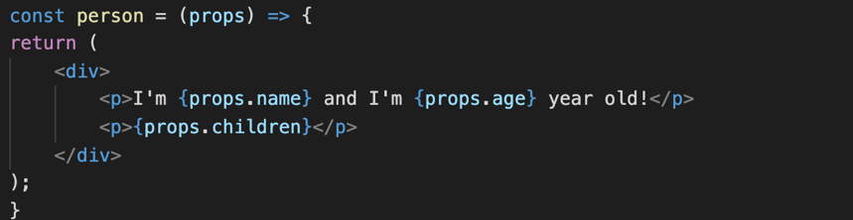
* You can get the text in between tags
* Those with text will show, those without will have empty <p> tags

• Understanding and Using State



* Button to switch name
* Rn it’s hard coded
* Class has properties
* A unique property of a class that extends Component: state
* Whereas props are passed from outside
* State are controlled inside
* 
* State can be changed to update the DOM, rerendered 

• Props and State



 







Note that here, it’s onClick, not onclick



We don’t call switchNameHandler(), but call it without parenthesis since we’re just passing it, not running it 

You shouldn’t change state directly like this. Instead you wanna use ‘setState’ method that allows to update State property

* It takes object as an argument
* 
* Even if state has two properties, setState only updates the first one. It merges the updated version with the original, leaving otherState intact
* setState is only available in classbased components
* But since 16.8, you can use functional components

Stateless : no internal state management

Good practice to use as many stateless (presentational/dumb) as possible

Only use state in a couple really needed components

Passing Method References between Components

 

You can pass methods as props

Passing values to functions (switchNameHandler)



How do you pass in newName? Two ways to do that

1. Bind



1. Arrow function (Anonymous Function) = can be a little inefficient

